Creating a blank workspace as phase3-EndProject

Created a collection named as -Pet_ID_Testing

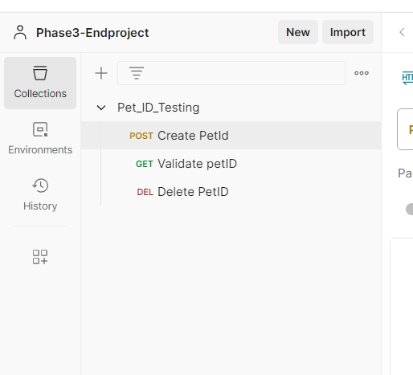

By clicking on the collection,then select the add request.

Then named as create petId

And selected method name as POST METHOD

Then given url -https://petstore.swagger.io/v2/pet

as shown below

{{petID}}

{{petName}}

Are parameterized in excel sheet.

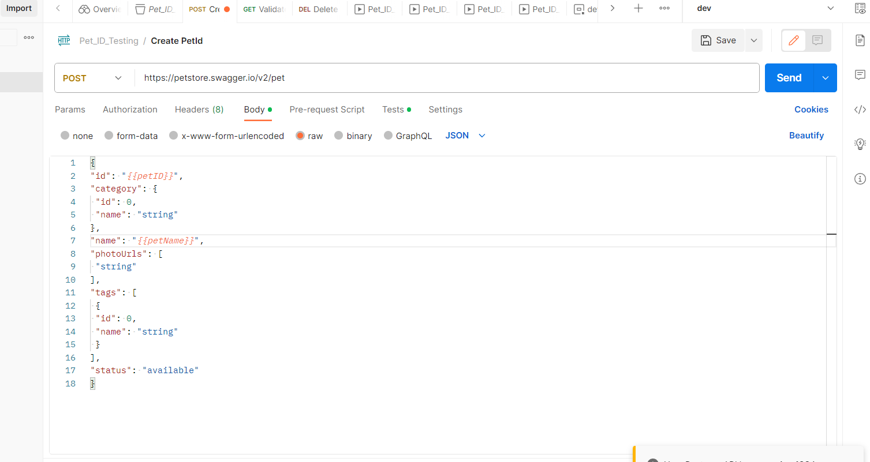

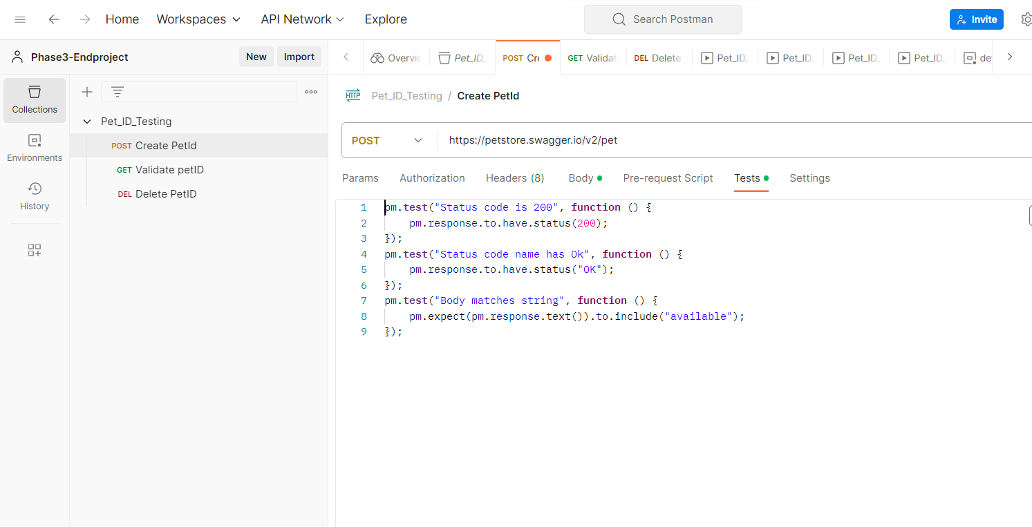

Creating a another request named as ValidatePetID

And given method as-GET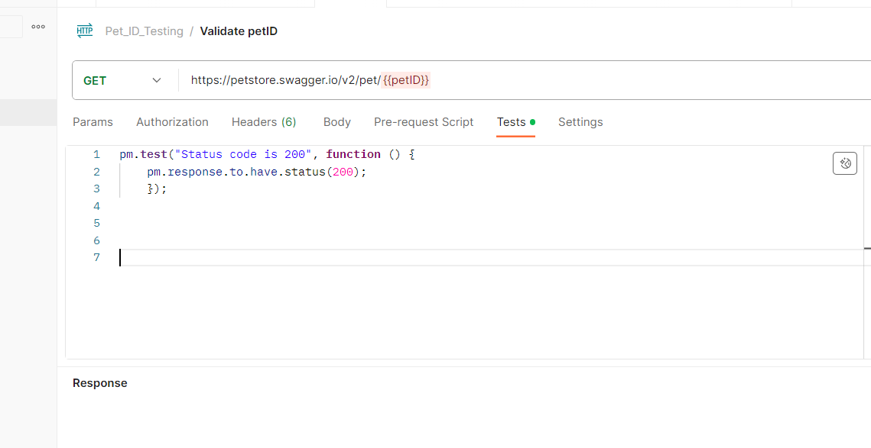

Then create another Add request named as Delete PetID

And given method as-DELETE

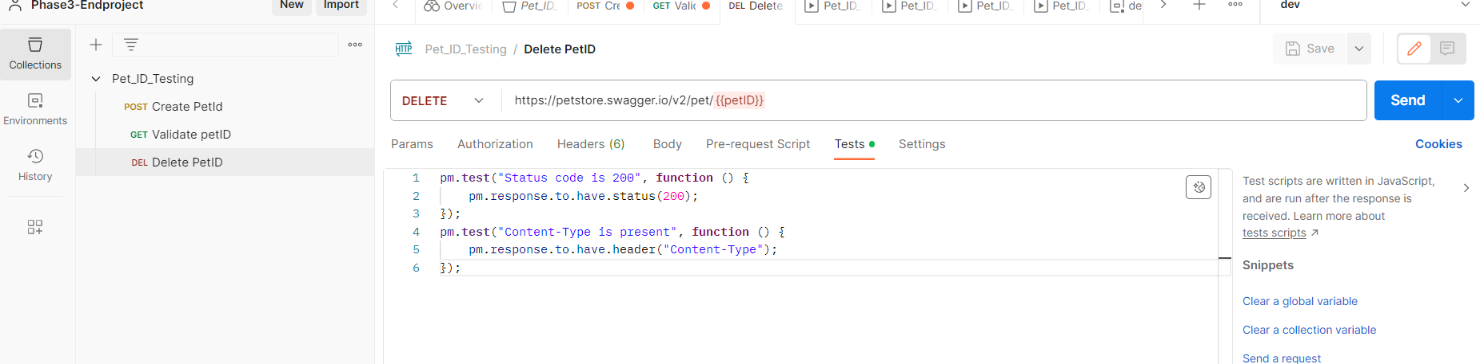

Running manually.

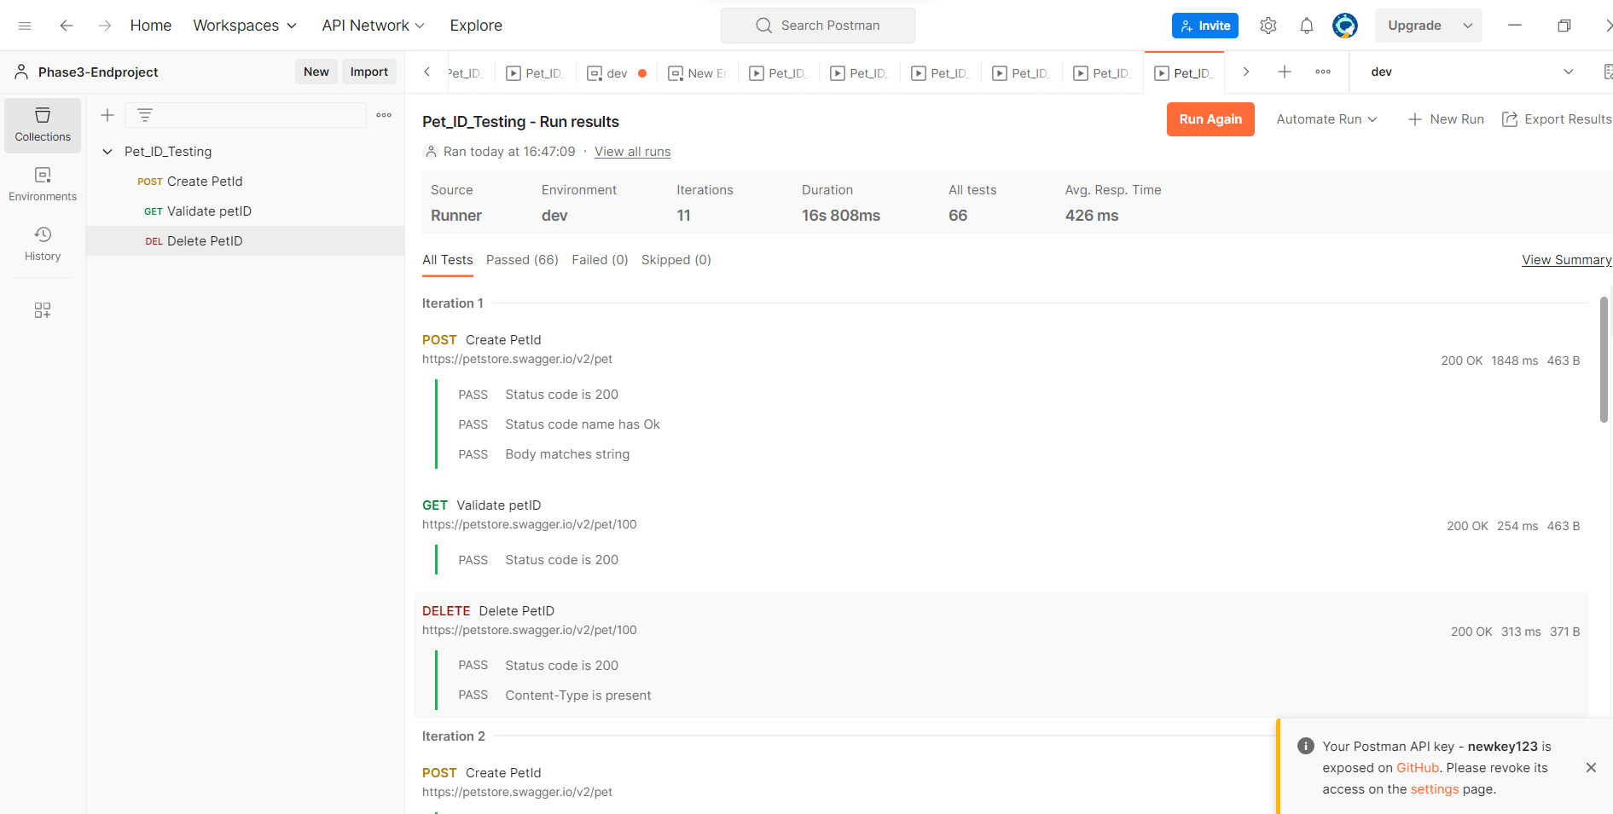

Assignment-002

Creating a global variable

testURL-https://petstore.swagger.io/v2/pet

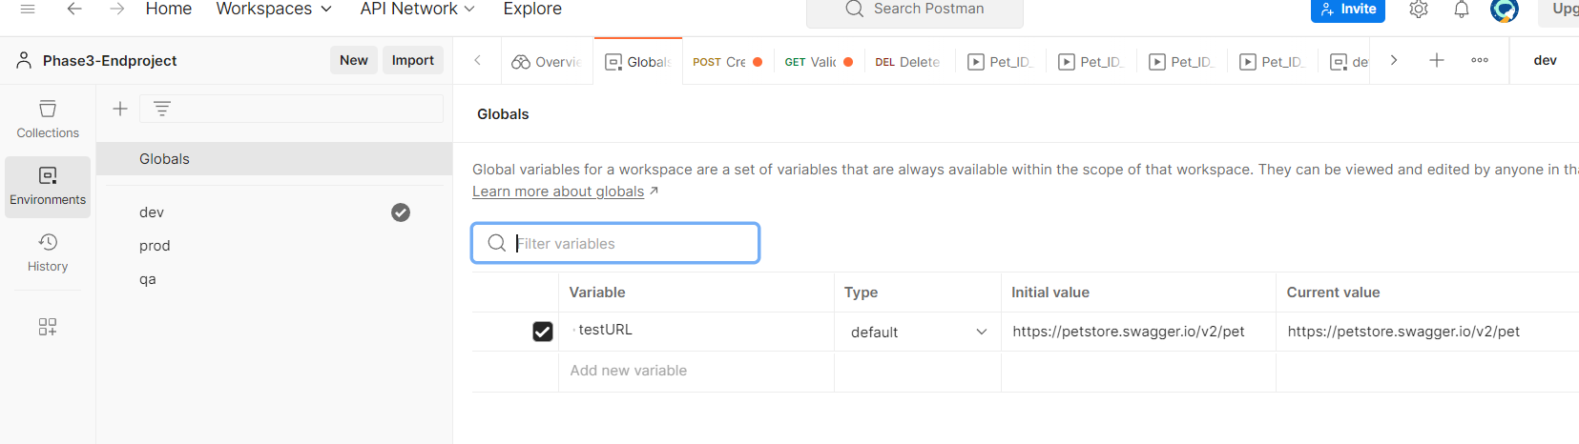

Creating environment variable for dev,prod,qa

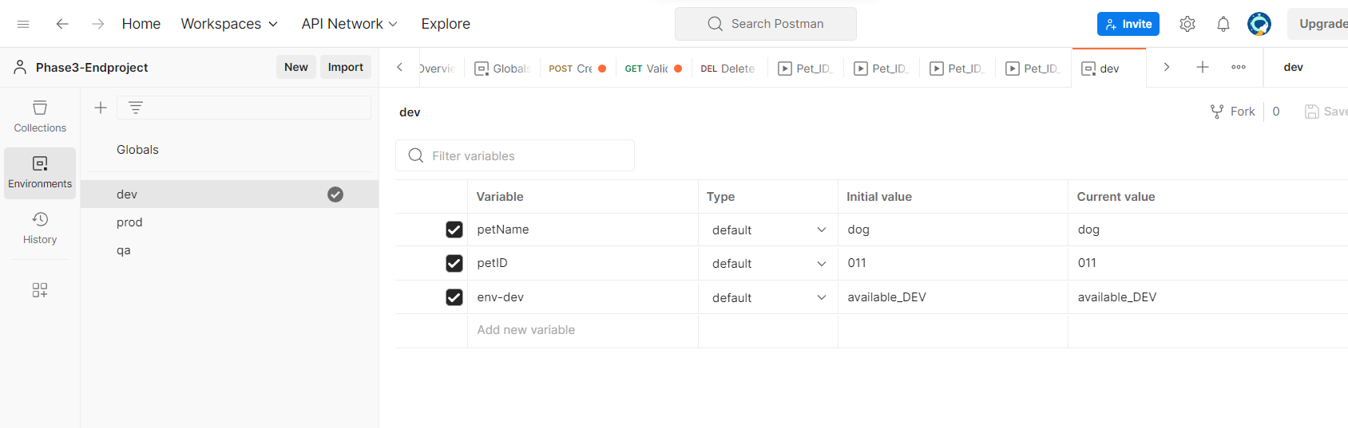

Calling the environment variable dev

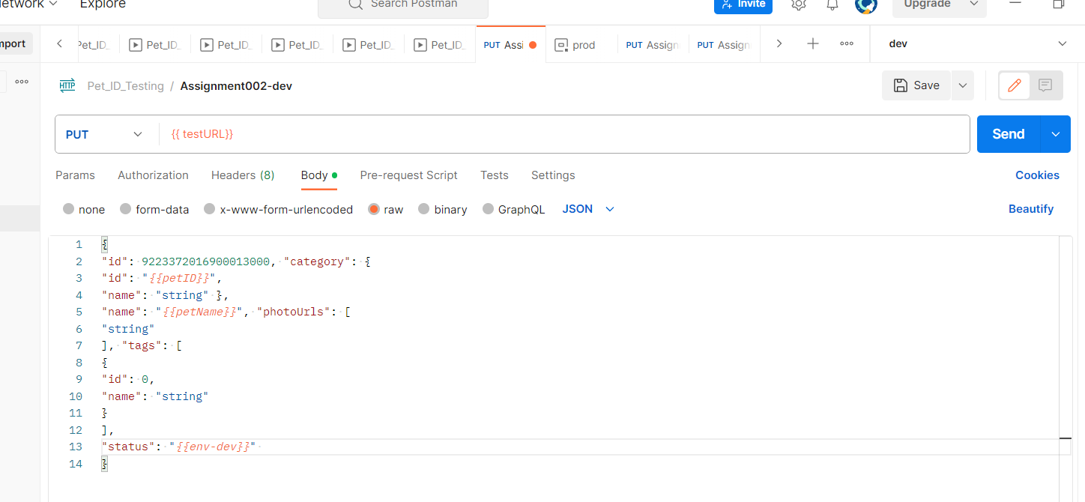

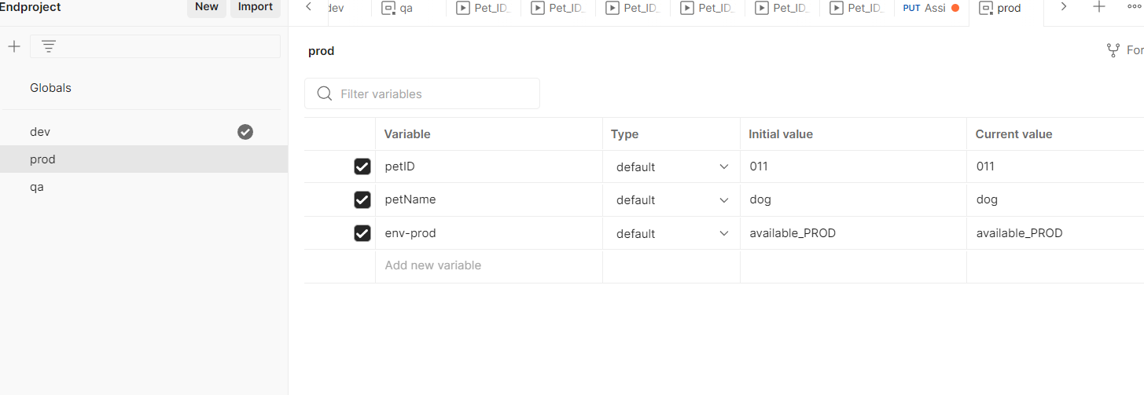

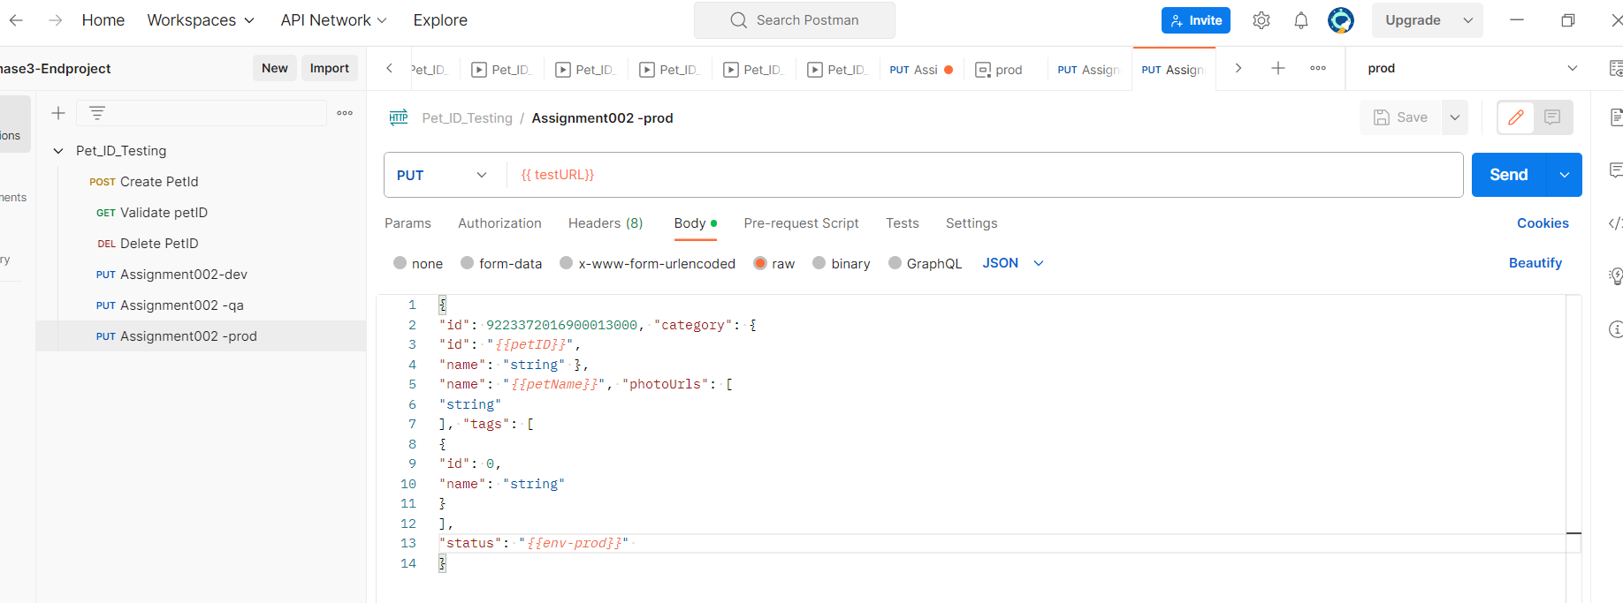

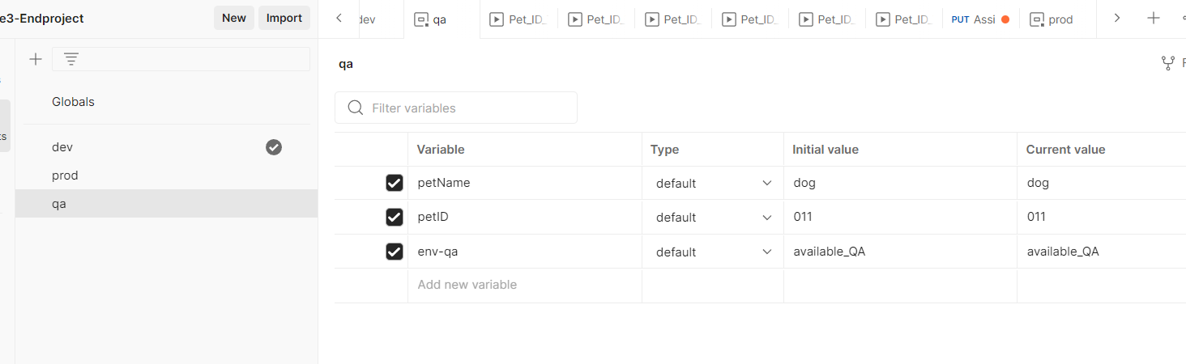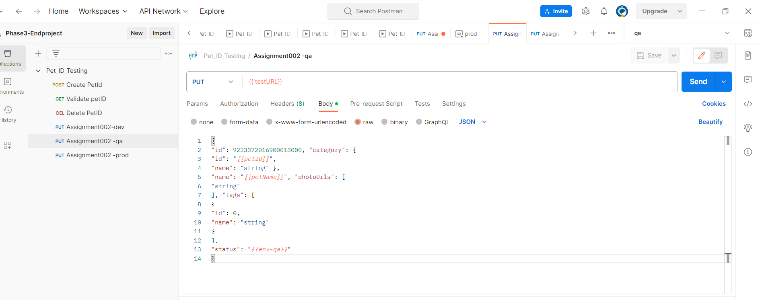

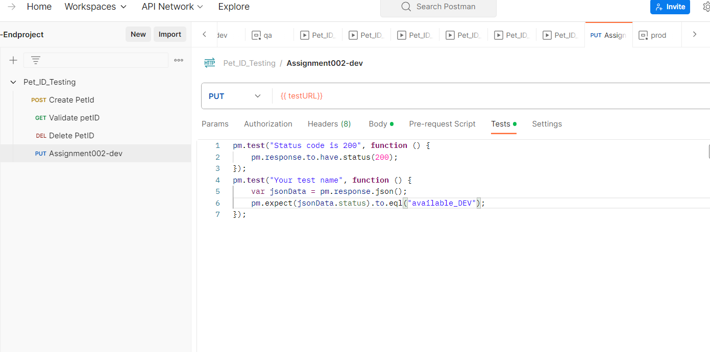

Assignment-003

Assigning global variable

Uname-Uname001

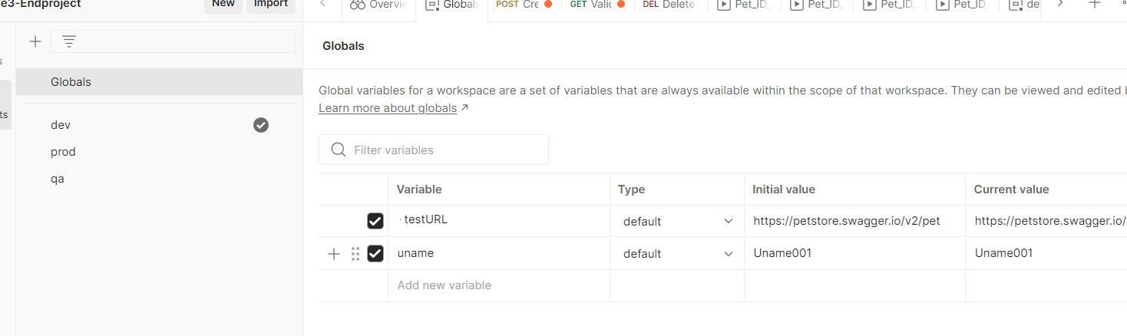

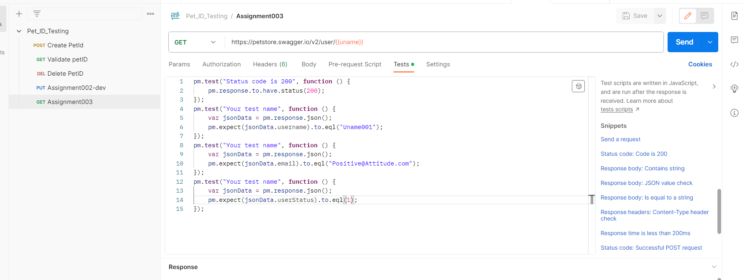

Assignment-004

Selected method is-GET

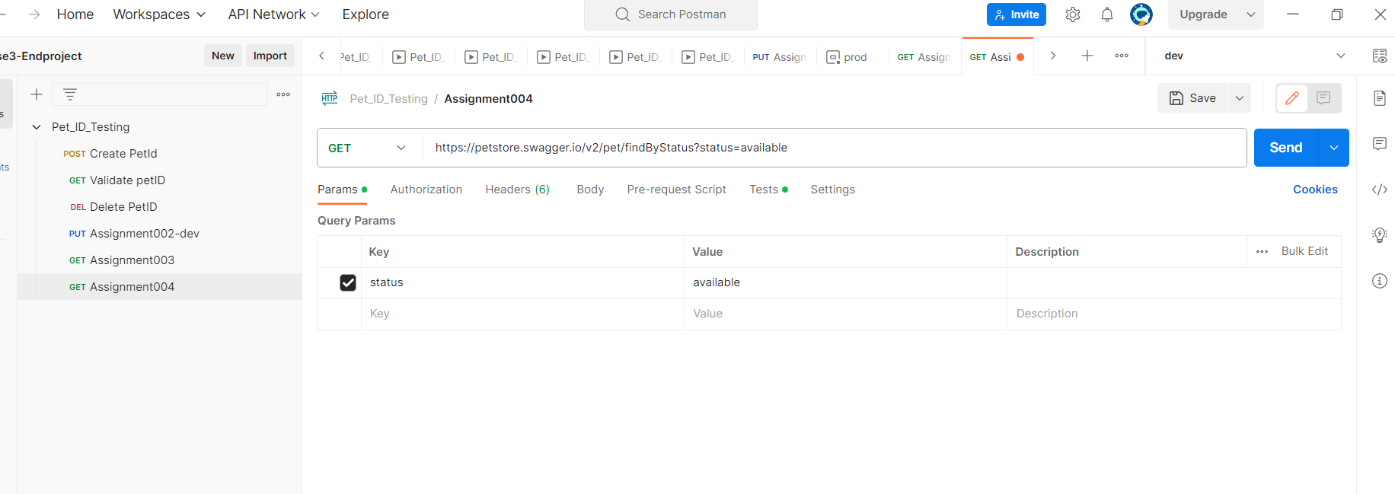

Checking the response code-200

And response message is”available”.

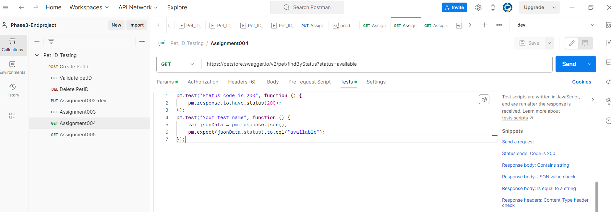

ASSIGNMENT-005

Selecting GET method

Given url=<https://petstore.swagger.io/v2/user/logout>

Then in test

Given assertion-validating wether the status code -200,and status message -OK

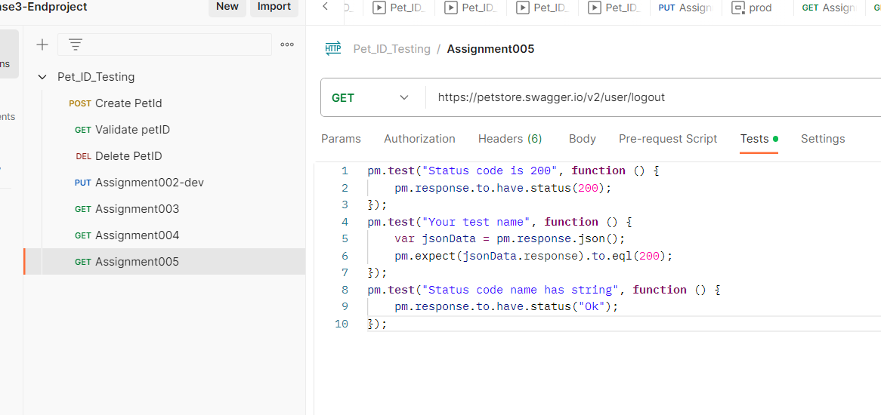

Right click on the collection then select the run collection option .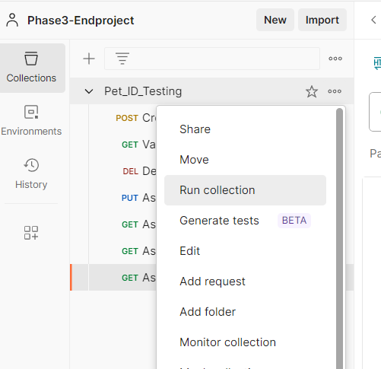

Select the request and select the run manually and click on the data file type and select the excel file.and click on the run button.

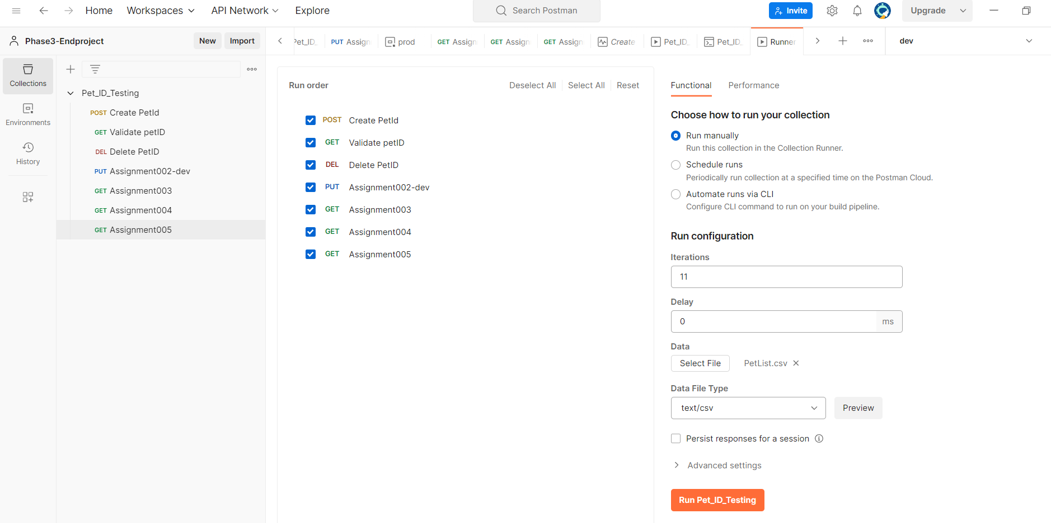

Running manually.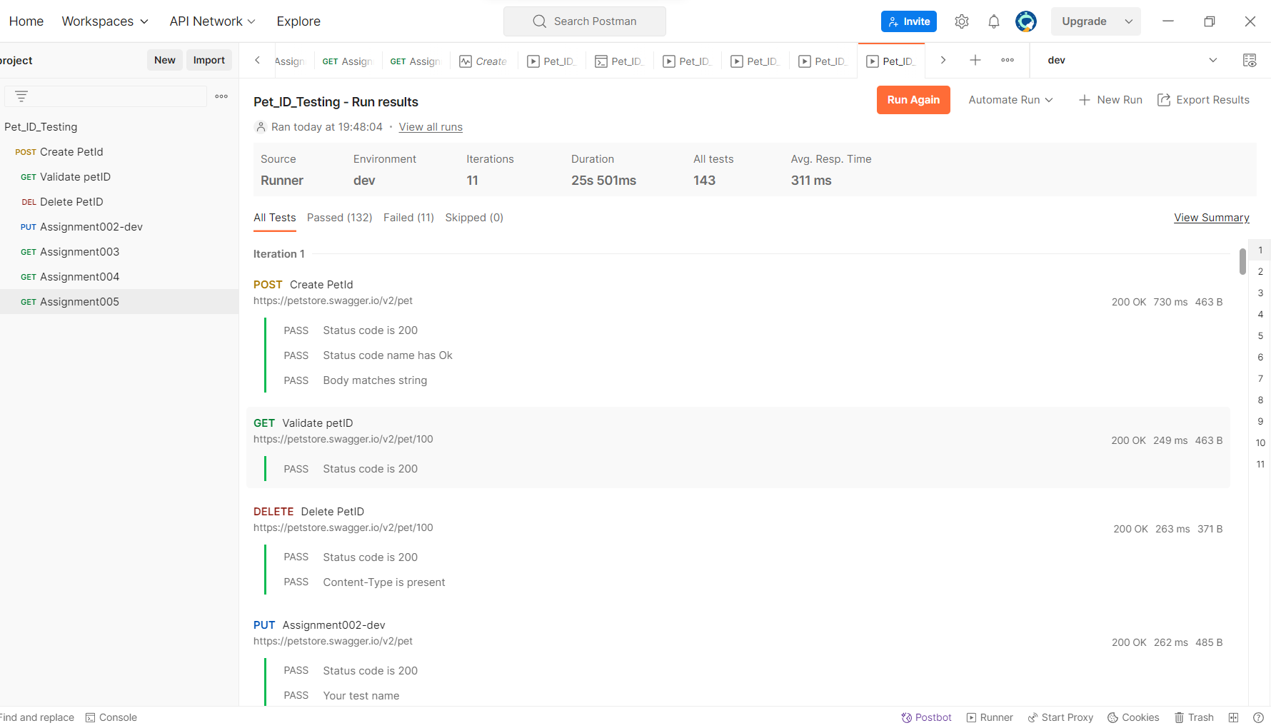

Petlist excel file

